TDLCB meeting handouts
January 13, 2021
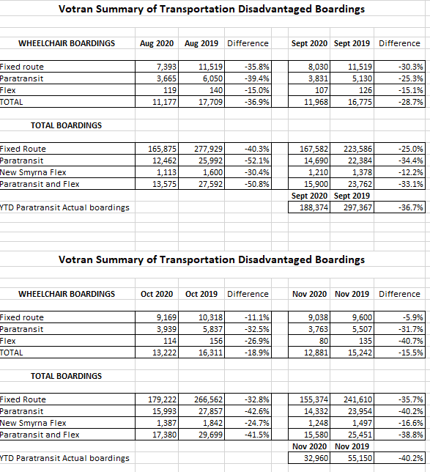

VOTRAN FLEX SERVICE REPORT – TDLCB meeting January 13, 2021

