ATTACHMENT "A"
Resolution 2014-##
Amending the
FY 2013/14 to FY 2017/18
Transportation Improvement Program (TIP)

April 23, 2014

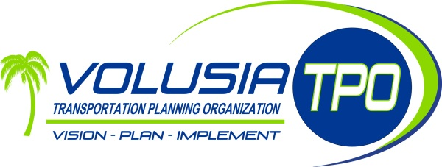

4349531 – Mason Avenue (SR 430) Rail Safety Project

Work Summary: Install 14 pairs of LEDs and 2 Gate Savers | From: 0.001 mile south of SR 430
 | To: 0.001 mile north of SR 430
Lead Agency: Florida Department of Transportation | Length: 0.002 mi

---------------------------- Current Adopted TIP ----------------------------
Phase | Fund  Source | 2013/14 | 2014/15 | 2015/16 | 2016/17 | 2017/18 | Total
CST | RHP | 0 | 0 | 0 | 0 | 0 | 0
CST | DIOH | 0 | 0 | 0 | 0 | 0 | 0
Total |  | $0 | $0 | $0 | $0 | $0 | $0

---------------------------- Proposed Amended TIP ----------------------------
Phase | Fund  Source | 2013/14 | 2014/15 | 2015/16 | 2016/17 | 2017/18 | Total
CST | RHP | 0 | 68,140 | 0 | 0 | 0 | 68,140
CST | DIOH | 0 | 1,997 | 0 | 0 | 0 | 1,997
Total |  | $0 | $70,137 | $0 | $0 | $0 | $70,137

Prior Year Cost:
Future Year Cost:
Total Project Cost: $70,137

Project Description: A Rail Safety Project – PE, Flagging, Parts, Labor and related costs to install 14 pairs of LEDs and 2 Gate Savers for Crossing #271932-T.

4349541 – Dunlawton Avenue (SR 421) Rail Safety Project

Work Summary: Install 21 pairs of LEDs | From: 0.001 mile south of SR 421
 | To: 0.001 mile north of SR 421
Lead Agency: Florida Department of Transportation | Length: 0.002 mi

---------------------------- Current Adopted TIP ----------------------------
Phase | Fund  Source | 2013/14 | 2014/15 | 2015/16 | 2016/17 | 2017/18 | Total
CST | RHP | 0 | 0 | 0 | 0 | 0 | 0
CST | DIOH | 0 | 0 | 0 | 0 | 0 | 0
Total |  | $0 | $0 | $0 | $0 | $0 | $0

---------------------------- Proposed Amended TIP ----------------------------
Phase | Fund  Source | 2013/14 | 2014/15 | 2015/16 | 2016/17 | 2017/18 | Total
CST | RHP | 0 | 78,760 | 0 | 0 | 0 | 78,760
CST | DIOH | 0 | 2,308 | 0 | 0 | 0 | 2,308
Total |  | $0 | $81,068 | $0 | $0 | $0 | $81,068

Prior Year Cost:
Future Year Cost:
Total Project Cost: $81,068

Project Description: A Rail Safety Project – PE, Flagging, Parts, Labor and related costs to install 21 pairs of LEDs.

